**Web Application Security**

**Assignment 1:**

**Objective:**

To Perform a SQL injection attack on a vulnerable web application (such as DVWA or OWASP Juice Shop) and extract information from the database.

Performing a SQL injection attack involves exploiting vulnerabilities in a web application’s input validation to execute malicious SQL queries and extract data from the database. I performed in DVWA (Damn Vulnerable Web Application) set up in a controlled lab environment.

* SQL Injection:
  + Classic/Error-Based: uses abnormal inputs to provoke database error messages or altered queries.
  + Blind SQLi: relies on boolean or time-based responses when error messages aren’t exposed.
  + Union-Based: leverages UNION queries to combine results from different Select statements.

**SQL Injection Attack on DVWA (Damn Vulnerable Web Application)**

1. **Setup**

* DVWA (Damn Vulnerable Web Application) is a deliberately insecure web application intended for security training.
* Running in a local, isolated environment at the low security level provides a safe setting to learn about common web vulnerabilities, including input handling and basic exploitation concepts, without impacting external systems.

**Environment and prerequisites**

* A Linux distribution (e.g., Ubuntu) or Windows with a local stack (e.g., XAMPP) or a containerized environment (Docker) to host a web server and a database.
* A local web server (Apache or equivalent) and a database server (MySQL/MariaDB) configured to serve DVWA.
* DVWA files downloaded from its repository and placed in the webroot (e.g., /var/www/html/dvwa or equivalent in XAMPP’s htdocs).

**Typical setup steps (high level, non-destructive)**

* Install and start a web server and database service.
* Deploy DVWA into the webroot and configure the database connection with a dedicated DVWA database user.
* Adjust PHP and server configuration as needed to enable DVWA (e.g., database access, required PHP modules).
* Open the DVWA setup page in a browser and initialize the database, then log in with the provided credentials (often admin/password or configured during setup).
* Set the DVWA security level to low for an educational baseline, taking care to note the boundaries of the lab (no external access).

**2. Identify Injection Point**

* Navigate to the SQL Injection page in DVWA.
* Typically, there is a form or URL parameter where user input is sent directly to database queries.

**3. Basic Injection Attempts**

* Common payloads to test:
  + 1' OR '1'='1 (to bypass login or retrieve all data)

**4. Extract Data**

* Input the payload in the vulnerable input field and submit.
* If vulnerable, the database will return more data than intended, such as user credentials.

**5. Example Payload:**

text

1' OR '1'='1

This crafts a SQL query like:

sql

**SELECT** * **FROM** users **WHERE** id = '1' OR '1'='1';

which returns all users.

ID: 1' or 1=1#'  
First name: Gordon  
Surname: Brown

ID: 1' or 1=1#'  
First name: Hack  
Surname: Me

ID: 1' or 1=1#'  
First name: Pablo  
Surname: Picasso

ID: 1' or 1=1#'  
First name: Bob  
Surname: Smith

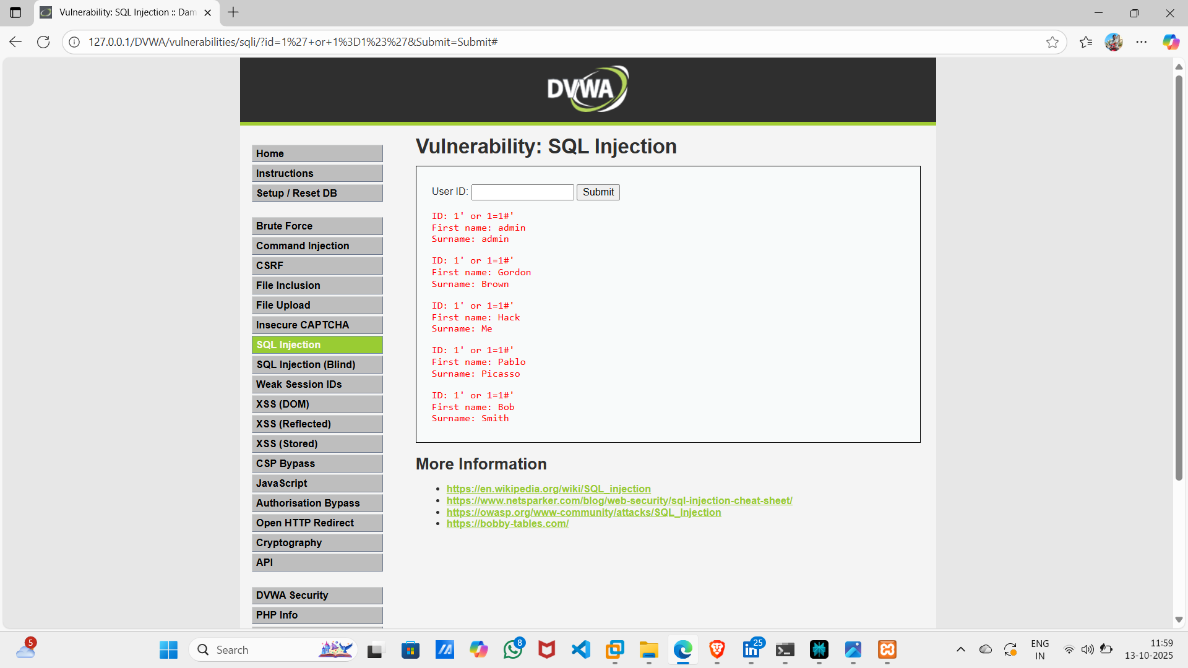

This POC

**Conclusion:**

Here I get all the user data.

I used payload 1’ or 1=1#’